OFFICIAL COORDINATION REQUEST FOR
NON-ROUTINE OPERATIONS AND MAINTENANCE

COORDINATION TITLE – 17 IHR 05 Turbine Rehab Ventilator
COORDINATION DATE – 20 April 2017
PROJECT – CENWWW-ODH - Ice Harbor Dam
RESPONSE DATE – 5 May 2017

Description of the problem; A ventilator is being used to maintain air quality in the workspace during construction activities associated with rehabilitation of Turbine Unit #2. The ventilator is positioned on the powerhouse tailrace deck adjacent to the powerhouse main entrance, which places it within 50 ft of the south shore fishway entrance and within 100 ft of the south shore fish ladder. The ventilator produces a high level of noise and some vibration. The ventilator is planned to be used for the next few years associate with rehab of units 2, 3, and 1. From now until the end of May the ventilator will be operated 12 hrs per day, 0600 to 1800 hrs. From June until November work will move to 24 hrs per day (two 12 hr shifts) and the ventilator will be run continuously.

Type of outage required; None

Dates of impacts/repairs: Present until 2020

Length of time for repairs: Present until 2020.

Impact on fish facility operation: None.

Impact on project operations None.

Analysis of potential impacts to fish. To include: The primary concern is that noise and vibration from the ventilator may impact adult salmon and steelhead behavior associated with passage in the south shore fishway.

- 10-year average counts during the dates of impact for adults for each affected listed species.
  - Adult 10 yr averages at Ice Harbor Dam by species are;
Chinook Steelhead Coho Sockeye Lamprey
160,212 166,033 4,427 959 417
- 10-year average counts by ladder.
  - Adult 10 yr averages for the South Shore Fishway at Ice Harbor Dam by species are;
Chinook Steelhead Coho Sockeye Lamprey
128,939 144,090 4,010 664 192
- Statement about the current year’s run (e.g., higher or lower than 10-year average).
  - The forecast for 2017 is lower than average returns for Chinook salmon and steelhead and higher than average coho salmon and Snake River sockeye salmon numbers.
- Estimated exposure to impact for adults and/or juveniles, as appropriate, by species (number or percentage of the 10 yr average that occurs during dates of action).
Exposure will depend on the amount of time the ventilator is operated during the year. Except for lamprey (46%) the majority of salmon (69% sockeye, 80% Chinook, 87% steelhead and 91% coho) are counted at the south shore fishway count station.
- Type of impact for adults and/or juveniles, as appropriate, by species (increased delay, exposure to predation, exposure to a route of higher injury/mortality rate, exposure to higher TDG, etc.).
The concern is that noise and vibration from the ventilator may be detected by fish in and near the fishway. Preliminary analysis conducted in 2016 at Lower Granite Dam found low to no correlations between fish behavior and vibration and sounds associated with construction work on the new juvenile fish facility. This supports our judgement that operation of the ventilator will have little to no impact to adult salmon and steelhead passage at Ice Harbor Dam.

Final judgement on scale of expected impacts (negligible, minor, significant) on;
  - Downstream migrants: None
  - Upstream migrants (including Bull Trout): Negligible
  - Lamprey: Negligible

Comments from agencies

Final coordination results

After Action update.

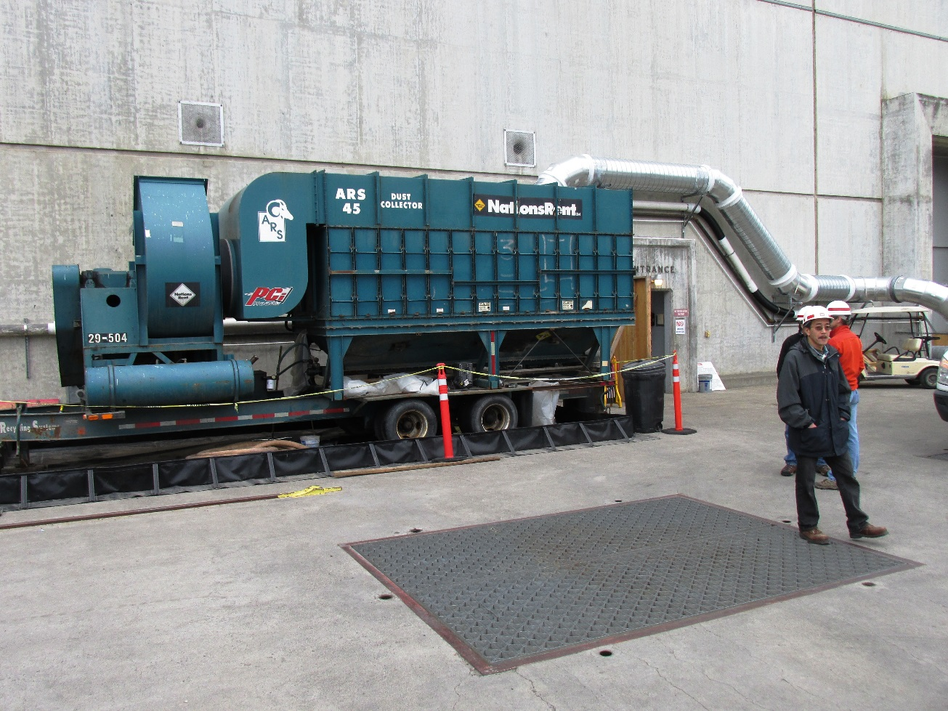

Please email or call with questions or concerns.
Thank you,

Ken Fone
Project Fish Biologist, Ice Harbor Dam
kenneth.r.fone@usace.army.mil

